

Space, Range and Merchandising Programme

Business Systems Design
for
Ranging Controls

Author: Anne Broderick, Sue Buchanan

Date: 11 May 2006

Version: 2.0

For sign-off:
Janet Smith | Space, Range & Merchandising Programme Director
Danielle Coe | Infrastructure Programme 3 Project Manager
Adam Harrison | IT SRM Project Manager
Jim Clifton | SRM Planning and Change Manager
Neil Hollins | Head of Space
Marcel Borlin | IT Development Programme Manager
Copied for information:
Steve Player | GT&A
Iain Hamilton | Space Data and Systems Manager
Mark Croft | Operations Manager
Jayesh Patel | Project Manager – Retail Range
John Wootton | Project Manager - Assort
Meryl Hanlon | IT Project Manager - Ranging
Nick Robbins | IT Project Manager
Paula McCarthy | Step Change programme Project Manager

Document Control
Date | Author | Change Description | Version
27/09/05 | A Broderick | Initial Draft | 0.1
27/02/06 | A Broderick | Reviewed version | 1.0
11/05/06 | S Buchanan | Updated to reflect changes in the Ranging Controls delivery content and timings | 1.1
26/05/06 | S Buchanan | Base-lined for release to HSC | 2.0

Contents

1 INTRODUCTION 5
1.1 Background 5
1.2 Purpose of Document 6
1.3 Objectives 6
1.4 Deliverables 6
1.5 Benefits 6
1.6 Assumptions 6
2 “AS IS” BUSINESS PROCESS 8
2.1 Existing Process Description 8
2.2 Issues with Current Process 8
2.3 Current System & Architecture 9
2.3.1 Current System 9
2.3.2 Current Architecture 10
3 “TO BE” BUSINESS PROCESS 11
3.1 Process Overview 11
3.2 Login Procedure 11
3.3 Main Menu 12
3.4 Space, Range and Merchandising Settings 12
3.5 Security Processes 13
3.6 Implications 14
3.6.1 Roles & Responsibilities 14
3.6.2 Other Implications 14
3.7 System & Architectural Changes 14
3.7.1 System Changes 14
3.7.2 Architectural Changes 15
4 REQUIREMENTS 17
4.1 Business Process Requirements 17
4.2 System Requirements 18
4.3 Non-Functional Requirements 19
5 SOLUTION ISSUES, RISKS & OPTIONS CONSIDERED 20
5.1 Issues 20
5.2 Risks 20
5.3 Other Options Considered 20
6 SYSTEM DESIGN 21
6.1 Screen RAC00: Login 21
6.1.1 Navigation 21
6.1.2 Screen 21
6.1.3 Field Descriptions 22
6.1.4 Process Flow 22
6.1.5 Exception Handling 22
6.1.6 Security Access 22
6.2 Screen RAC 01: Main Menu 23
Navigation 23
6.2.2 Screen 23
6.2.3 Field Descriptions 23
6.2.4 Process Flow 24
6.2.5 Security Access 25
6.3 Space, Range and Merchandising Settings 26
6.3.1 Screen RAC 02: Space, Range and Merchandising Settings Menu 26
6.3.2 Screen RAC 04: Merchandising Group Maintenance - Settings 29
6.3.3 Screen RAC 03: Space, Range and Merchandising Schedule Settings 32
6.4 Screen RAC 05: Space, Range and Merchandising Uploads 35
6.4.1 Navigation 35
6.4.2 Screen 35
6.4.3 Field Descriptions 35
6.4.4 Process Flow 35
6.4.5 Exception Handling 36
6.4.6 Security Access 36
6.5 Error Handling 37
6.5.1 Error Codes 37

INTRODUCTION

Background
The Ranging Controls is designed to replace a set of disparate tools and processes used by different teams within different departments with one, centrally controlled and co-ordinated system, operated by a central team.

This document describes the front end of the Ranging Controls, where the users log into the main menu that will take them into the various system applications.

These processes cover a variety of tasks, including maintaining data that is core to the Space, Range and Merchandising processes, that allows the business to make decisions about the ranges to go into a store.

A series of Business System Design (BSD) documents are being produced to describe the various components of the new system, as shown by the diagram below. The elements highlighted are covered in this document.
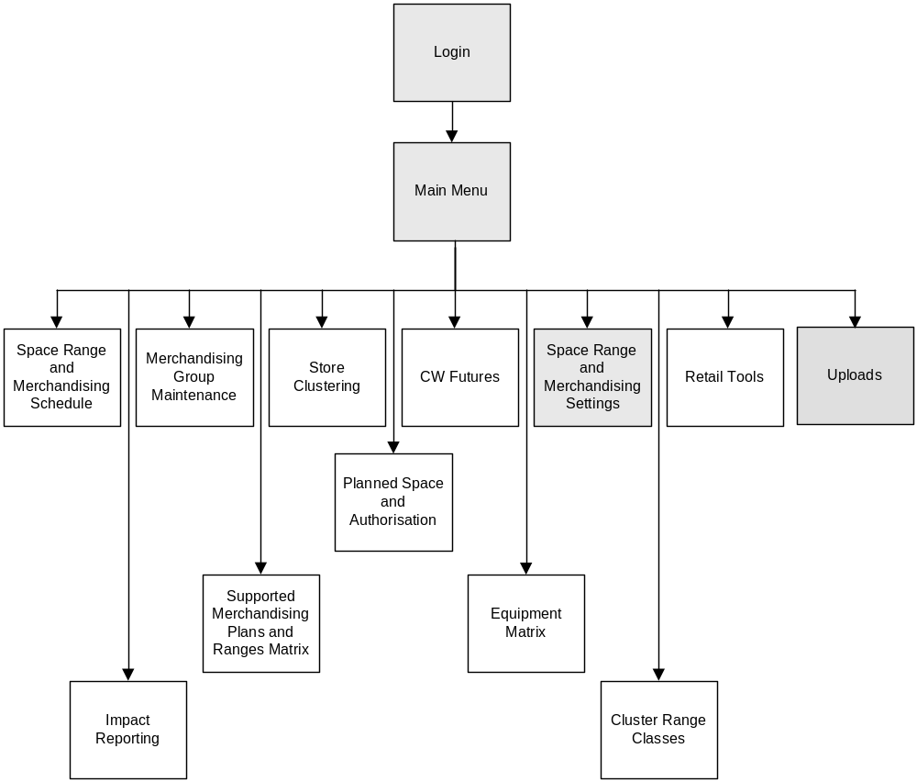

Purpose of Document
This document describes the top-level system that supports the functionality described in the other, related BSDs.

It encompasses both the business requirements and a detailed description of the business functions required and should provide sufficient detail to enable the Technical System Design (TSD) to be written.

Objectives
The Ranging Controls applications will provide access to the infrastructure through which to centrally control the business functionality described in the associated BSDs. The existing mixture of manual and semi-automated procedures will be replaced with one new system, making the tasks easier to perform and less subject to human error.

The system will be designed using new technology (.net on SQL server), providing a flexible business solution that is simple to use, that has a consistent look and feel and can be readily enhanced, as necessary.

Deliverables
As a result of this document a new intranet site will be provided for use by the Space, Range, and Merchandising teams, which will house the majority of the functionality they require to do their job.

The environment will be secure, providing a means for the Operations team to control user access on a day to day basis, system by system.

Benefits
One central system using one common source of data will be more secure and will help to eliminate any problems with data sources being out of sync. The whole process will be operating on “one version of the truth”, which will be more accurate through more timely updates.

Ranging Controls will run on simpler technology, which will result in a more efficient system that is easier to maintain.

Improved access and timeliness of systems will deliver a more efficient solution that is more readily available to the business.

The effect of any decisions made affecting one aspect of the system will be quickly reflected elsewhere and its impact understood by the central team. Communication of changes will become far more effective.

Assumptions
One of the applications supported by the Ranging Controls application will be the Pre-Ranging process, which is already under development. It is assumed that it will be readily assimilated into the Ranging Controls because the same technology and databases will be used.

It is assumed that all users of the system have access to the intranet, as this is a web-based solution.

It is also assumed that all the necessary hardware will be available and that Ranging Controls will work on any Windows-based environment.

As the various tasks are being brought together under one system it is assumed that a new RACI will be agreed before implementation and that it can be implemented via the security controls

“AS IS” BUSINESS PROCESS

Existing Process Description
A number of different activities take place which come together to provide the infrastructure for a merchandising event. These activities may take place at different times on different and often unconnected systems, managed by different teams.

The system diagram at section 2.3 gives a flavour of the activities that take place to enable changes to be made for a scheduled Merchandising Event.

Some of the activities shown happen concurrently; others are dependent on earlier activities having been completed.

As each of these activities is described in detail in the supporting BSDs it has been decided not to describe the processes again here.

Issues with Current Process
At present people in different sections of the business use a variety of different tools for the various tasks. It is labour intensive and subject to human error, and requires expert knowledge on old, complicated legacy systems.

The processes are disconnected, so that a change made in one tool is not automatically reflected elsewhere. The process relies on the verbal communication of changes being made.

Because many of the processes are manual, little or no validation takes place and there is limited security surrounding the tools or data.

There is no clear RACI around the end to end process and, due to the lack of visibility, there is little understanding of the consequences of making changes.
This can result in deadlines being missed.

It should be noted that the solutions to these issues are not covered by this document alone, but by all of the BSDs documenting the development of the Ranging Controls.

Current System & Architecture

Current System

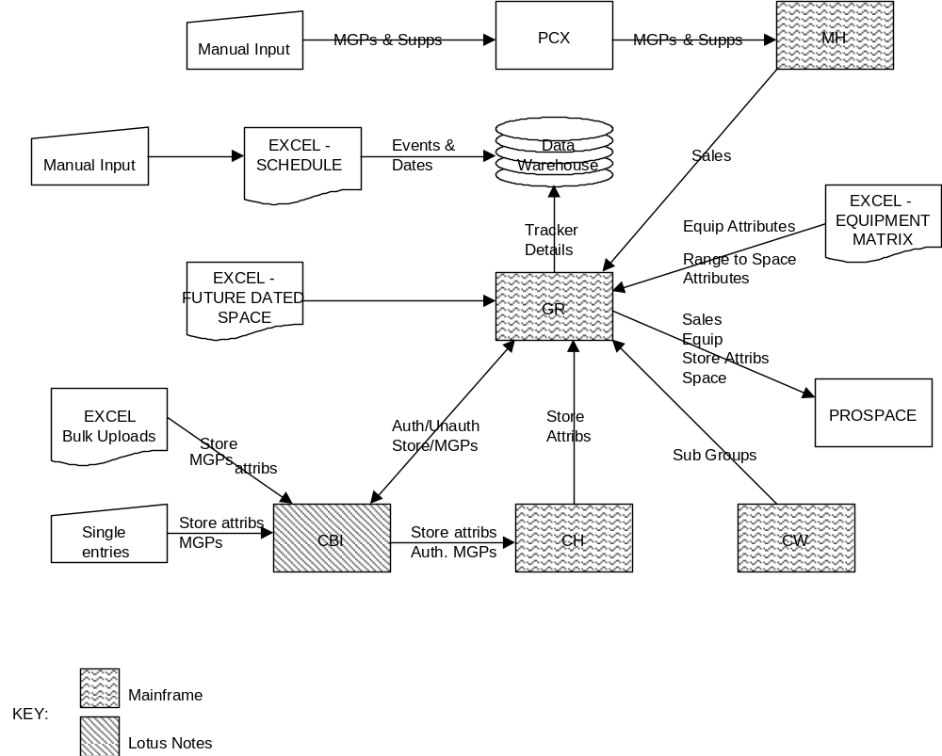

Current Architecture

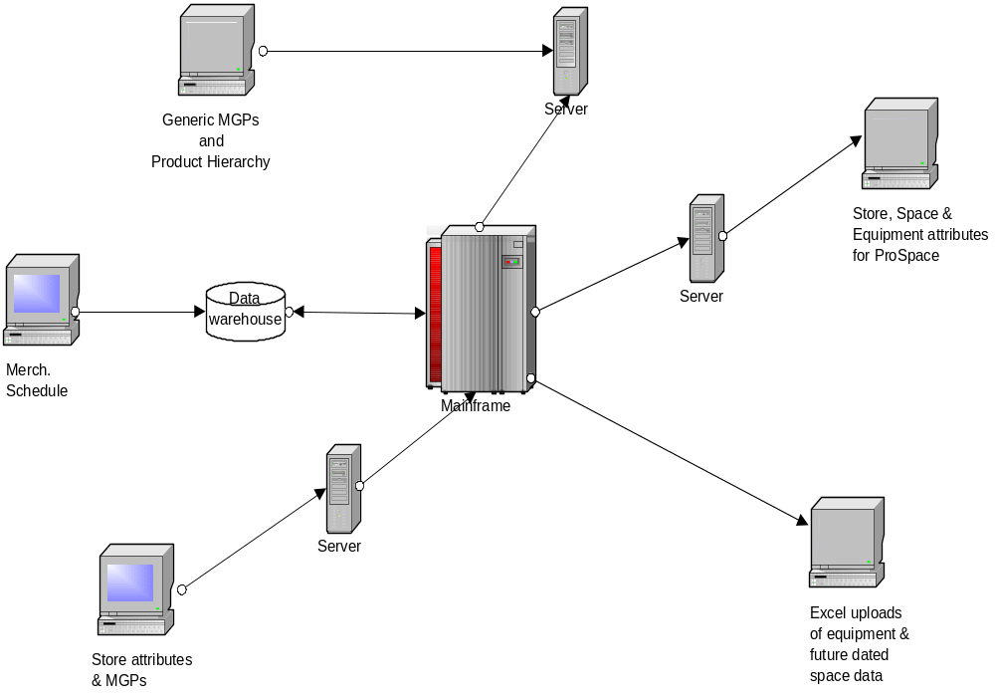

“TO BE” BUSINESS PROCESS
All screen layouts can be found in section 6.2 but are only indicative.

Process Overview

Login Procedure
To gain access to the system the user will either type the intranet site’s name (URL) into the browser toolbar or select the icon provided on their application window.

This will put the user into the login screen where they will need to enter their password and user ID for verification and to determine the level of access they are permitted.

Once logged into the system they are passed to the Main Menu screen.

Main Menu
From this screen a user can only select one of the menu options, logoff or close the application down completely. There are no business processes to be performed relating to this screen.

Based on their security levels users will only be shown the options on the menu they have access to.

The Main Menu screen will act as the Home Page for all applications on the Ranging Controls.

Space, Range and Merchandising Settings
This is the area in which the control parameters for the business processes, other than those for security, are managed. The security controls will be managed trough the security section of the system.

If the user selects this option they will be presented with a selection menu that covers the areas for which controls can be set. Choosing one of these options takes the user into the appropriate controls screen.

Within the selected application the user can perform one of three tasks.

- Add a New Attribute to a setting

This provides the facility to add a new value to a control parameter. For example:

Add the new attribute ”refresh” to activity type in the controls for the Schedule

- Amend the attributes associated with an existing setting

- Delete a setting

The consequence of taking any of these actions is discussed in detail in each of the relevant BSDs.

It will not possible for the business to add new parameters as these require additional coding to handle it. Adding new parameters will always have to be requested through I.T.

Security Processes
Security for all Space Range and Merchandising applications will be managed through a single security controls application using standard Microsoft Windows security tools. For details, see BSD 22 SRM Tactical SRM Security Control System.

Three levels of access will be defined:
- Read
Users can only view the screens and data.

- Write
Users can view screens and update data.

- Superuser
Users can view screens, and update and delete data. They also have the permission to update and delete the application settings.

Using Microsoft tools, the business will be invited to define a series of user groups, operations and roles, which help to control user access at different levels. The users are then added to the appropriate groups and roles according to the tasks that they perform.

There are three processes relating directly to daily security procedures and a further one that relates to the set up of the environment. The responsibility for performing these tasks will be managed by the business team, but these roles have yet to be fully defined.
1. Manage users and passwords
The security administrators will be responsible for adding and removing users from the system and for granting and revoking their access privileges within each of the applications.
On a day-to-day basis the security administrators will be responsible for resetting passwords, as necessary. Part of this task will be to ensure that an appropriate level of authority has approved each request.

2. Monitor system activity
For Ranging Controls Phase A, system activity monitoring will not be available.
All system activity (except view only) will be logged.

3. Manage security controls
These tasks form part of setting up the security environment.

The number of login attempts that are allowed before a user is locked out of the system, the length of the password cycle, the length and format of passwords all have to be pre-set.

The tasks will be handled through the tools provided by Microsoft Windows to support the security applications.

Implications

Roles & Responsibilities
A new, small group of users are being brought together to manage the Ranging Controls and some of the processes of which it is comprised.

This will reduce the number of people needing authority to access the systems. Although staff based in Cirrus will perform most of the activities it will still be necessary to make the applications available at other sites. Occasionally a team member may be working at a different office (Cheshunt or Progress House) or the Merchandising Centre, so it will be necessary to make the applications available at any named sites.

Some of the management of user security and access will fall to the business, but the extent has yet to be established.

Other Implications
The first phase of the Pre-Ranging development will be launched prior to the development of the Ranging Controls.

It is intended to bring the Pre-Ranging Settings into the Ranging Controls environment, as part of the second phase of development for Pre-Ranging. As it has been developed using very similar style and standards to the Ranging Controls it is expected that minimal re-engineering will be required.

Similarly work on Retail Range Settings is progressing. Although the development teams are liasing it is possible that some re-engineering will need to take place to bring the Retail Range Settings into line with the Ranging Controls.

Messages about application availability within the Ranging Controls will be visible to all users when they login, even if they relate to applications they do not have access to.

System & Architectural Changes

System Changes
The tools for setting up and enabling a merchandising event to take place will now be central and contained within one system, the Ranging Controls, which is completely new.

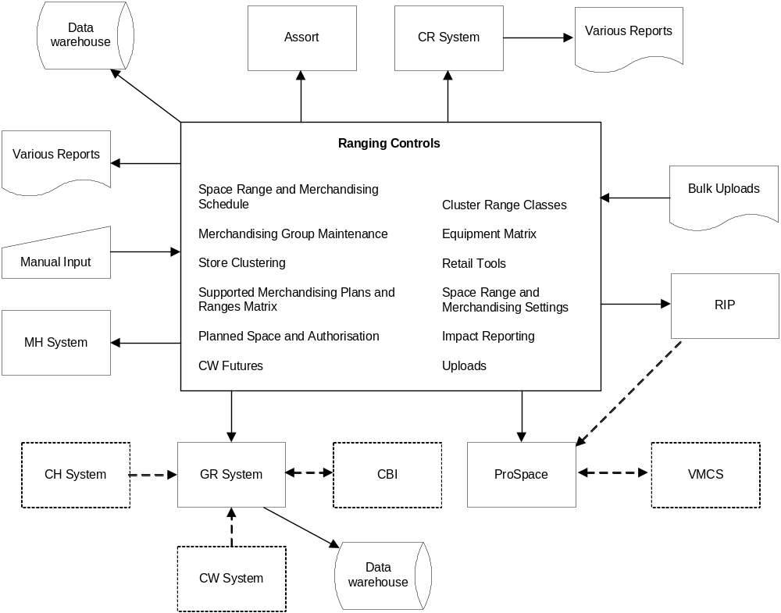

The boxes shown with the broken outlines will not be directly impacted by the development of the Ranging Controls, but are shown for completeness.

Architectural Changes
The architecture for the Ranging Controls is entirely new, but the external interfaces remain similar to those at present.

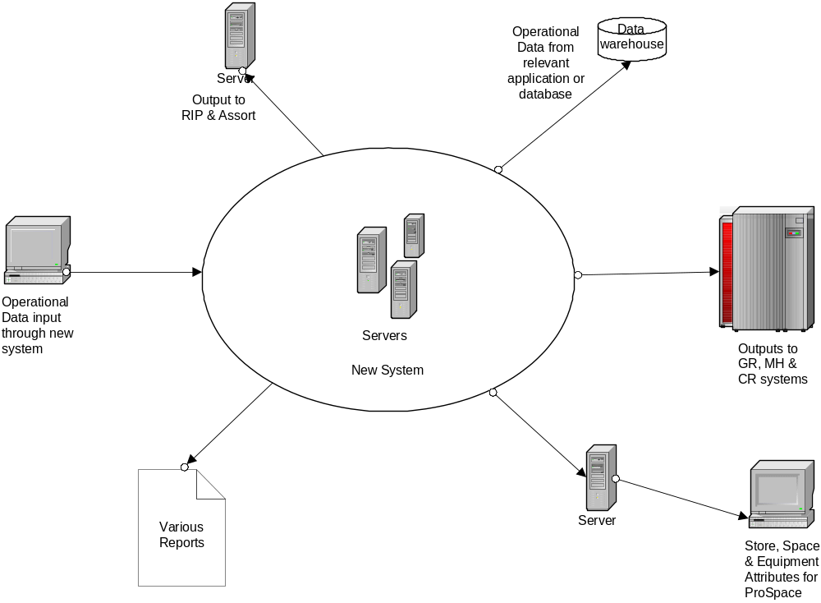

REQUIREMENTS

Business Process Requirements
To enable the business to make full use of the facilities contained within the Ranging Controls the following requirements will need to be satisfied:

- User authentication when attempting to log into the system.

- Attempts to login by unauthorised users will result in an appropriate warning message being displayed.

- Only users with appropriate access level will see the security menu options.

- All authenticated users will see all the infrastructure menu options. However, only those options that a user has security access to use will be available to them; any options a user does not have security access to use will be unavailable (greyed-out). .

- Only one menu option may be selected at a time.

- Three levels of user access are required:

- Read only
- Read and write
- Super user

- A user may have different access rights for each of the applications.

E.g. a user maybe authorised to only read the Merch. Group Maintenance data, but have read/write access to Pre-Ranging.

Similarly, a user may have Super User access to the Schedule, but read only to the Planned Space application.

- Ultimately access will be through the portal provided as part of the Simpler Desktop programme, but in the interim login and security procedures will have to be provided. Some of the following requirements only relate to non-Simpler Desktop users.

- On addition of a new user the system will automatically assign a password, which the user will need to change when they first log in.

- When resetting a password the system will automatically generate a new default password.

- The period of time that a password remains valid for will be parameterised and be managed through the controls within the security application.

- The number of attempts a user may make before their authority to access the system is revoked will be parameterised. After this time their password will need to be reset by a Super User and be managed through the controls within the security application.

- All activities will take place in real time.

System Requirements
The Ranging Controls comprises of a number of applications that have many interfaces with external systems, but this part of the system has none other than Security.

In order to meet the business requirements this top-level part of the system will comprise of:

- a login screen, which is displayed when the appropriate URL has been invoked,

- leading to a menu screen, providing the security and authentication checks were successful.

- Users should never be offered the option of allowing the system to ‘remember’ their password during the login process or at any other time.

- The User’s ID will be automatically populated based on the registered user for that machine, but can be overwritten if machine is being used by other user.

- The sequence of the menu options will always be the same irrelevant of which applications the user has access to.

- There will be no gaps left on the users menu where they do not have access to an application, and therefore will not see it on their menu.

- Except for Space Range and Merchandising Settings and Uploads, each of the options on the menu screen relates to a separate application, described in their own Business System Design (BSD) documents.
Space Range and Merchandising Settings and Uploads are described as part of this BSD.

- Only one window into the Ranging Controls application and its dependent applications may be open at any one time for each user.

- Having selected an application, control is passed to the chosen application, taking any appropriate data with it.

- The navigation through the screens and systems will be through the one window, using the standardised navigation toolbar (as described in the Design Standards and each application BSD).

- An audit trail will record all changes made throughout the system.

All screens must adhere to the Ranging Controls Screen Design Standards.

Non-Functional Requirements
The non-functional requirements specified for the system are common throughout all of the infrastructure systems. See the Non-Functional Requirements document for details.

SOLUTION ISSUES, RISKS & OPTIONS CONSIDERED

Issues
There are currently no known issues.

Risks
Failure to deliver this development to the timelines will impact the Operations team ability to access the dependent Space, Range and Merchandising Event Management functions and applications, as they are being developed on the basis that this front end will provide user access.

If there are not enough people with the appropriate authority to set new users up on the system, it may not be possible to provide full cover during working hours and to cover for holidays and sickness. This needs to be covered when determining the security roles as part of the RACI.

Other Options Considered
The alternative to having one central system for the applications that relate to setting up the infrastructure for a Merchandising Event is to continue with a series of disconnected applications.

This approach may present problems in getting the applications to communicate, which could result in poor data management. It would also require each application to have its own security procedures, so every user would need a separate password for each application.

SYSTEM DESIGN

All screens will be built following the Space, Range and Merchandising Screen Design Standards.

Screen RAC00: Login
Used by anyone attempting to sign into the Ranging Controls.

Typing the intranet site’s name (URL) into the browser toolbar or by selecting the appropriate icon from the user’s application window will provide access to the system’s login screen.

Navigation

Login

Screen
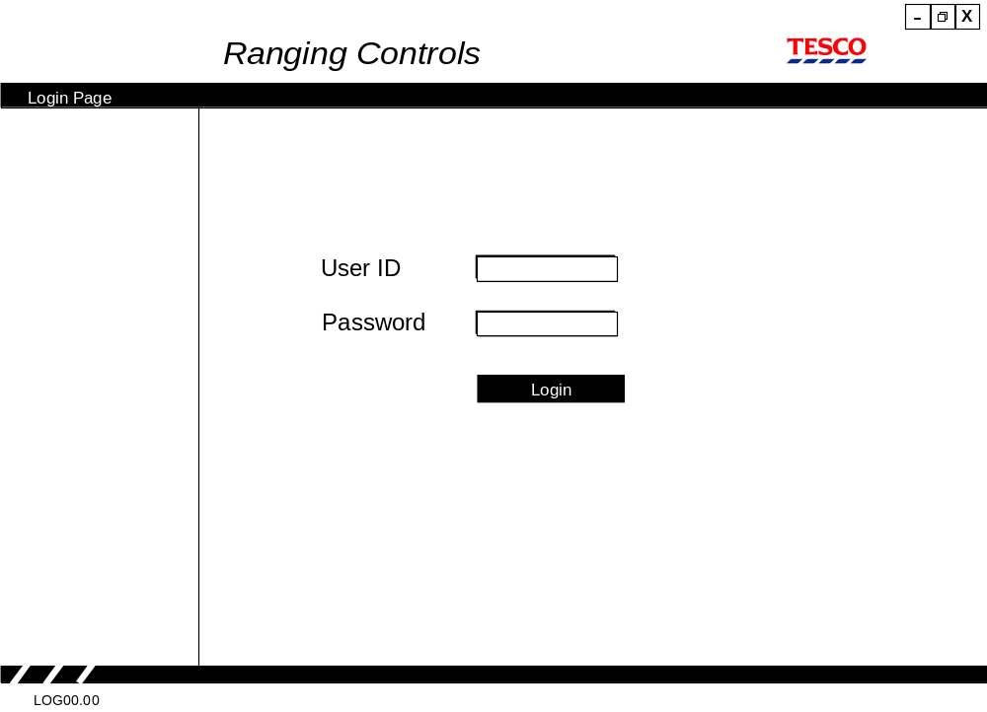

Field Descriptions
Field | Description | Comments
User ID | The User’s standard Tesco ID | Pre-populated based on default for that machine
Password | A user defined password | See section 6.4 for further details on passwords

Process Flow
The login screen is accessed through typing an intranet site address on the toolbar, or, via the icon supplied in the user’s application window.

Security validation and monitoring is handled by the Security application. See BSD 22 SRM Tactical SRM Security Control System.

Providing they are authorised to access the system they will be passed through to the Main Menu screen.

Exception Handling
Entering incorrect, invalid or expired passwords or user IDs will result in a suitable message being displayed.

These messages are controlled by the Security application. See BSD 22 SRM Tactical SRM Security Control System.

Security Access
Access to this screen = All users

Screen RAC 01: Main Menu
The main menu screen offers the user access (dependent on their security level) to the selected application.

Navigation

Login

Main Menu

Screen
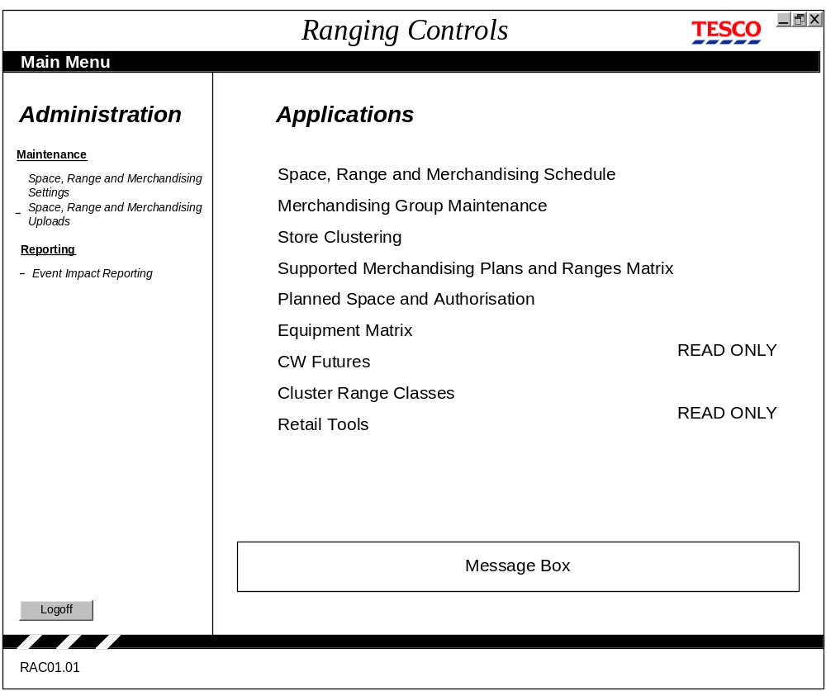

Field Descriptions
This is primarily a selection screen to help the user navigate to the part of the system they require.

All options will be displayed; those options a user does not have security access to use will be available (i.e. greyed-out). The sequence options are shown in will be consistent across all users and based on the sequence of the ‘Full’ menu list. If a user has read-only access to an option, the words READ ONLY will appear next to the option name.

Although some of the options shown, e.g. Impact Reporting, are not currently on the project plan it is easier to build the application with the provision of adding it in at a later date.

The message box will be used to show both system generated messages when applications are unavailable (e.g. when the Merchandising Groups are being uploaded to the mainframe) and the users will also be able to type in messages regarding system availability. The box will be maintained on a daily basis to prevent old messages accruing.

Process Flow
From this screen a user can only select one of the menu optionslogoff, or close the application down completely.

On selection of a menu option (by clicking on the required application) the user’s level of authority to access the application is assessedby checking the user’s ID against the authorisation table prior to passing them through to the application.

On selecting an application the user’s ID and details are carried forward for further authentication.

For Phase A of Ranging Controls, the following options will be available:
- Space Range and Merchandising Schedule
- Merchandising Group Maintenance
- Store Clustering
- Retail Tools
- Space Range and Merchandising Settings
- Uploads

If the user selects this … | This will happen …
Space Range and Merchandising Schedule | The entry screen for this application is displayed. See the Space Range and Merchandising Schedule BSD.
Merchandising Group Maintenance | The entry screen for this application is displayed. See the Merchandising Group Maintenance BSD.
Store Clustering | The login screen for Pre-Ranging 1 is displayed. This application will be built and operational by the time Ranging Controls Phase A is launched.
Retail Tools | The login screen for Retail Tools is displayed. This application will be built and operational by the time Ranging Controls Phase A is launched.
Space Range and Merchandising Settings | The Space Range and Merchandising Settings screen is displayed, as described in section 6.3
Uploads | The Uploads screen is displayed, as described in section ???.

The other applications will be shown on the Main Menu but will be unavailable (i.e. greyed out). These applications will be made available at subsequent phases of Ranging Controls, for which this document will be re-issued under change control conditions.

Security Access
Access to this screen = All users

Space, Range and Merchandising Settings
There are 5 sub-screens to this part of the application, one for each main application. Later BSDs introducing new applications (e.g. Planned Space) will add new options and screens to this menu.

Screen RAC 02: Space, Range and Merchandising Settings Menu

Navigation

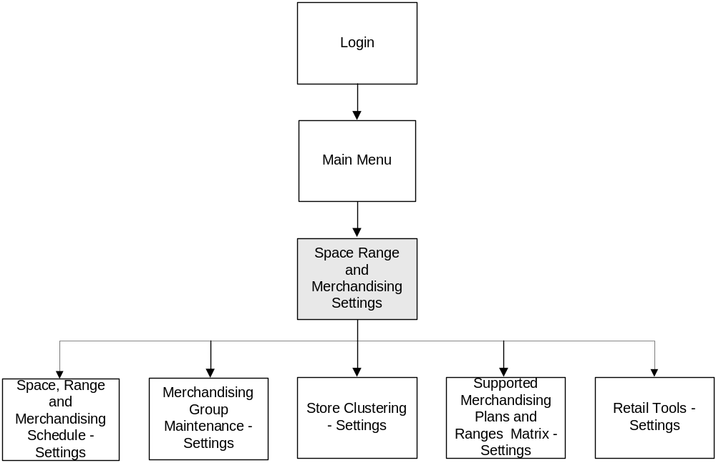
Screen

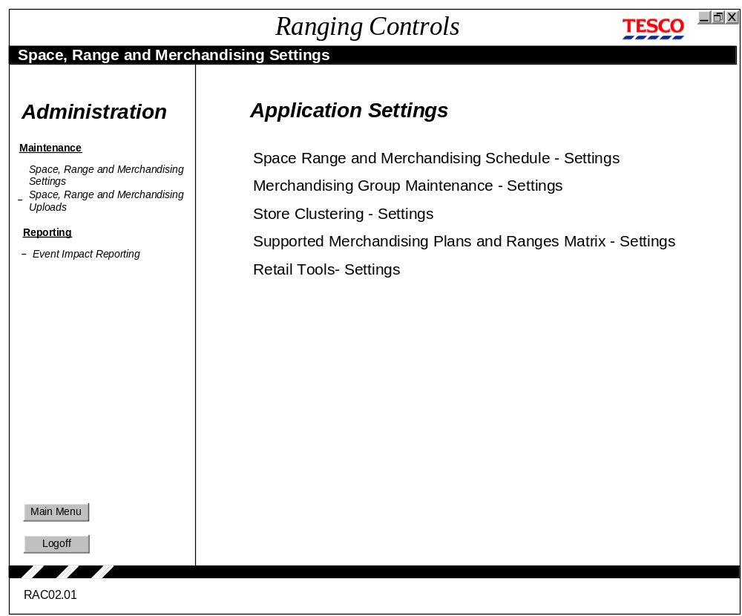

Field Descriptions
There are no updateable fields on this screen. It is purely a selection menu to help the user navigate to the Settings screen for the selected application.

Process Flow
From this screen a user can only select one of the menu options (by clicking on its name), return to the Main Menu, or logoff from Ranging Controls.

In all instances the user’s authorisation to access the selected application is validated by checking the user’s ID against the authorisation table prior to passing them through to the application.

On successful access to a selected application the user’s ID and details are carried forward for further authentication.

For Phase A of Ranging Controls, the following options will be available:
- Space Range and Merchandising Schedule
- Merchandising Group Maintenance

If the user selects this … | This will happen …
Space Range and Merchandising Schedule | Display screen RAC03, Space Range and Merchandising Schedule – Settings
Merchandising Group Maintenance | Display screen RAC04, Merchandising Group Maintenance – Settings

The other three options will be appear on the screen as unavailable (i.e. greyed out)
- Store Clustering
- Supported Merchandising Plans and Ranges Matrix
- Retail Tools

Although Store Clustering and Retail Tools will be available for Phase A, their settings will be handled within their own application and not as part of the Ranging Controls. However, all three of these options will be made available at subsequent phases of Ranging Controls, for which this document will be re-issued under change control conditions.

Exception Handling
If a user is not authorised to use the option they select, the following message is displayed: You are not authorised to use this option. This should be handled in conjunction with the Security application.

Security Access
Access to this screen = Superusers

Screen RAC 04: Merchandising Group Maintenance - Settings

Navigation

LOGIN

MAIN
MENU

SETTINGS
MERCHANDISING GROUP
MAINTENANCE -
SETTINGS

Screen

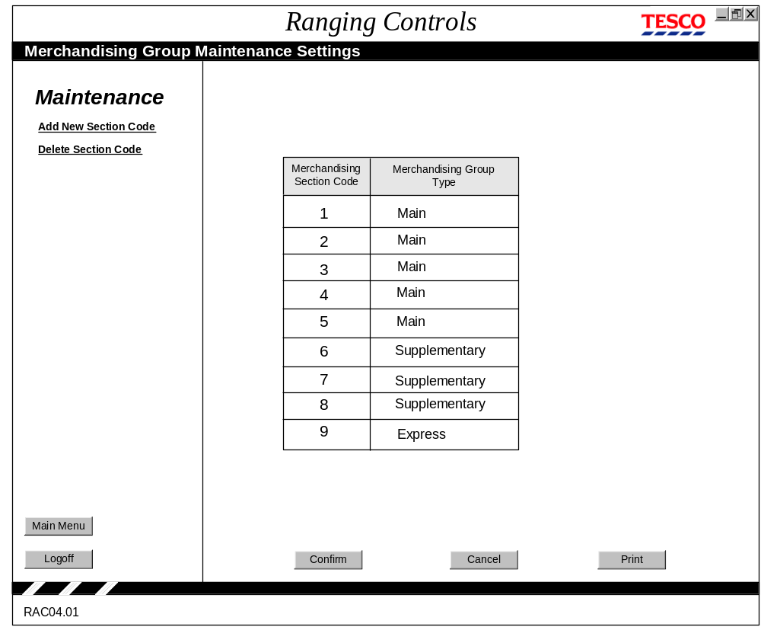

Field Descriptions

Field | Description | Comments
Merchandising Section Code |  | Options: A single numeric value
Merchandising Group Type | Description of the merchandising group type. | Options: Main, Supplementary and Express.

Process Flow
The screen is opened in an edit mode, which means the user can tab to any of the fields and make changes to them.

If the user selects Add New Section Code, the cursor goes to the top of the Merchandising Section Code column and opens a new, empty row so that one can be added. After a new section code has been entered the cursor will automatically move to the Merchandising Group Type column, where a drop down menu offering the three available types are shown. One should be selected. When confirm is selected the new value that has been entered is validated and a message displayed to say the transaction was successful . The next time the screen is opened, the Merchandising Section Codes are displayed in numeric order.

To delete a section code, the user selects a row in the table then selects Delete Section Code from the navigation menu. The row is marked for deletion but the deletion is not actioned until the Confirm button is pressed. When Confirm is pressed, a warning message is displayed: You have requested the deletion of Section Code n. Are you sure? Yes- delete code, No - do not delete code.

When the Confirm button is selected the new data is validated and upon successful completion of the transaction, an advisory message is displayed: “Update successful”. Focus remains on the screen.

When the Cancel button is selected, if any changes have been made to a screen a warning message is displayed: Selecting Cancel will lose the changes you have made. Are you sure you want to cancel the changes? Yes/No. Selecting Yes will delete any changes the user made and return the screen values to what they were when the screen was first opened (or after the last Confirm/Successful Transaction.) If no changes were made, selecting Cancel will do nothing – focus remains on the screen.

When the Print button is selected, the Content area of the screen is printed.

Exception Handling
If, when adding a new section code, a duplicate value to an existing one is entered, the field should be highlighted, the cursor placed on the field and an advisory message: Description already exists (no. 9) is displayed.

If an alpha character or other non-numeric character is entered into the Section Code field, the cursor should be placed on the field and the field highlighted and an advisory message: Data entered must be numeric (no. 2) is displayed.

When the Confirm button is pressed, if a new Merchandising Section Code has been added, but no Merchandising Group Type selected, the cursor is placed in the Merchandising Group Type field and an advisory message displayed: Select a Merchandising Group Type.

Security Access
Access to this screen = Superuser

Screen RAC 03: Space, Range and Merchandising Schedule Settings

Navigation

LOGIN

MAIN
MENU

SETTINGS
SRM
SCHEDULE
SETTINGS

Screen
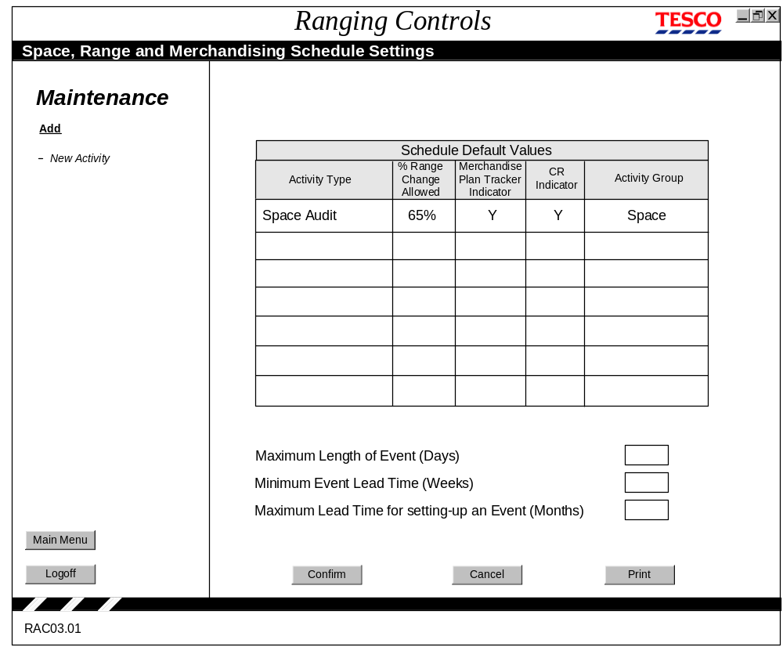

Field Descriptions
Field | Description | Comments
Activity Type | The type of event to be included on the schedule, used to build the drop-down selection list on the Schedule | For example, New, Update, Refresh, Space Audit, etc.
Percentage of Range Change Allowed | The percentage of variance from the proscribed range allowed | A numeric value from 1 to 100
Merchandise Plan Tracker Indicator | To indicate whether the activity should be included on the tracker report | Options: Y or N  Default is Y
CR Indicator | Sets the default value on the Schedule, used to dictate whether or not to pass information to CR.. | Options: Y or N  Default is Y
Activity Group | Used to group together activity types that are similar, e.g. New, Update and Refresh are all Merchandising Activities.  Determines which table the event gets written to on the database. | Options: Space, Merchandising, Out Of Cycle  Default is blank
Minimum Event Lead Time (Weeks) | The minimum number of weeks lead time required when adding an event to the schedule | A positive numeric value, greater than 4 and up to 13.
Maximum Time in Future an Event can be set up (Months) | The maximum number of months ion the future that an event can be set up | A positive numeric value, between 1 and 24.
Maximum Length Time for setting-up an Event (Days) | The maximum length of any event | A positive numeric value, not greater than 31.

Process Flow
The screen opens in edit mode, i.e. all input fields can be edited. The cursor will automatically skip to each subsequent column after a value has been entered and/or either Enter or Tab has been selected.

If New Activity is selected the cursor goes to the top of the Activity Type column and opens a new, empty row so that a new event can be added. After a new event has been entered the cursor will automatically skip to each subsequent column after a value has been entered and either enter or tab has been selected.

When the Confirm button is selected the new data is validated and upon successful completion of the transaction, an advisory message: Transaction Successful (no. 30) is displayed. Focus remains on the screen.

When the Cancel button is selected, any new data the user has added to the screen is deleted, and the screen values returned to what they were when the screen was first opened, or after the last Confirm/Successful Transaction.

When the Print button is selected, the Content area of the screen is printed.

Exception Handling
During the add New Activity process the entire row must be completed. If any fields have not been completed the cursor should be placed on the incomplete fields in sequence (from left to right), highlighted and an advisory message Number 3 (Enter data into the indicated field(s). is displayed.

If a value greater than 100 or less than 1 is entered into the Percentage of Range Change Allowed field, put the cursor on the field, highlight it and issue an advisory message: Value must be between 1 and 100.

If a value greater than 13 or less than 4 is entered into the Minimum Event Lead Time field, put the cursor on the field, highlight it and issue an advisory message: Value must be greater than 4 and no greater than 13.

If a value greater than 24 or less than 1 is entered into the Maximum Time in Future an Event can be set up field, put the cursor on the field, highlight it and issue an advisory message: Value must be between 1 and 24.

If a value greater than 31 is entered into the Maximum Length of Event field, put the cursor on the field, highlight it and issue an advisory message: Value must be between 1 and 31.

Security Access
Access to this screen = Superuser

Screen RAC 05: Space, Range and Merchandising Uploads

Navigation
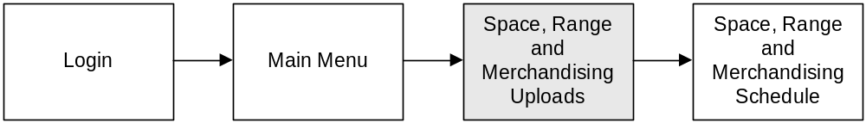

Screen

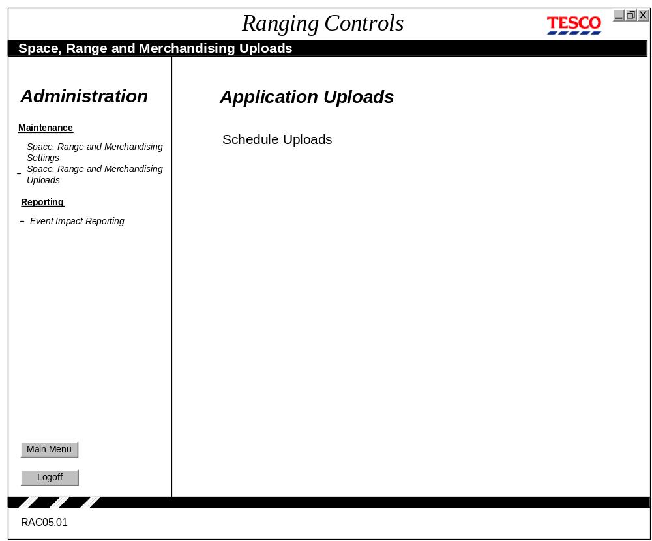

Field Descriptions
There are no updateable fields on this screen. It is purely a selection menu to help the user navigate to the Uploads screen for a the selected application. For Phase A or Ranging Controls, the only option available will be uploads for the Space, Range and Merchandising Schedule.

Process Flow
From this screen a user can only select one of the menu options or return to the Main Menu. For Ranging Controls Phase A there will be only one option: Schedule Uploads. When this option is selected, control is passed to the Schedule Uploads screen. The Schedule Uploads screen is described in the Space, Range and Merchandising Schedule BSD.

In all instances the user’s authorisation to access the selected application is validated by checking the user’s ID against the authorisation table prior to passing them through to the application. On successful access to a selected application the user’s ID and details are carried forward for further authentication.

Exception Handling
If a user is not authorised to see the option they select, the following message is displayed: You are not authorised to use this option. This should be handled in conjunction with the Security application.

Security Access
Access to this screen = Superuser

Error Handling

Error Codes
The following codes will apply for common errors:

Msg. No. | Message | Trigger
1 | Data entered must be alphabetic | Numerics detected in alpha field
2 | Data entered must be numeric | Alpha characters detected in numeric field
3 | Enter data into the indicated field(s). | Incomplete data
8 | Description already exists | Description validation failed
9 | Description is too long | User attempts to enter data after the end of the field is reached
10 | The description entered is the same as an existing one. Do you want to proceed? | Duplicate description found
11 | Choosing another task at this point will lose all changes made. Do you want to proceed? | Another option selected from the menu bar prior to pressing the “proceed” button
12 | Cancelling at this point will lose all changes made. Do you want to proceed? | Cancel button selected
13 | If you logoff at this point will lose all changes made. Do you want to proceed? | The logoff button is selected prior to pressing the “proceed” button
14 | Are you sure? | To confirm that selected action is correct
30 | Transaction successful | All data successfully validated and processed

